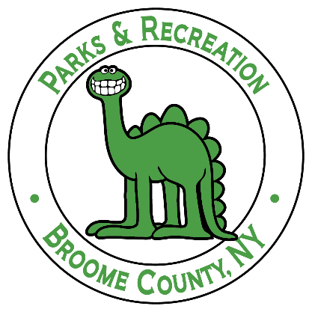

Rationale: Skin cancer is one of the most common cancers in the United States. The main cause of almost all forms of skin cancer is exposure to ultraviolet radiation (UV). Broome County Parks and Recreation Department recognizes skin cancer’s risk can be greatly reduced when precautions are practiced and is committed to ensuring that all its staff, volunteers, and public events are protected from UV radiation exposure. To help reduce the burden of skin cancer, Broome County Parks and Recreation Department will be implementing the following sun safety policy.
Objectives:
- To increase awareness of skin cancer and its preventative measures within staff, volunteers, and events messaging.
- Adopt sun safe policies for staff, consumers, and events in order to decrease exposure to UV radiation.
- To develop strategies which encourage responsible decision making about sun protection amongst staff, volunteers, and event goers.
Policy:
Employees
The following is Broome County Parks and Recreation’s employee sun safety practices. Staff are encouraged to adopt these behaviors any time they are on site.
Protective Clothing, Hats, Sunglasses
- Staff will wear sun-protective clothing and equipment when outside, year-round.
- Protective equipment includes:
  - A hat with a wide-brim that protects the face, neck, and ears
  - Safe and shatter resistant sunglasses with 100% UV protection
Sunscreen
- Staff will apply broad spectrum, water resistant sunscreen with a SPF of 15 or higher to all exposed areas and rub in well.
  - These areas will be especially applied:
    - Face
    - Nose
    - Ears
    - Feet
    - Hands
- Staff will be given access to sunscreen while onsite.
- Application will be prior to 30 minutes before exposure to the sun, and every additional two hours if in the sun for a long period of time.
- Staff will be given work time to apply sunscreen while onsite.
- If staff cannot use sunscreen for medical reasons, a note from a licensed provider must be given.
Shade Protection
- Staff will consider shading when planning outdoor events.
- Sufficient areas of shade will be provided during outdoor events, and staff will be encouraged to seek shaded areas when possible.
- Staff will remind and encourage volunteers and participants to seek shaded areas during outdoor events when possible.
- Staff will monitor the heat index and will adjust events accordingly. Staff will be monitored closely for heat-related illnesses.
- Sun exposure will be limited as much as possible during the hours of 10 AM and 4 PM, when UV radiation is the strongest.
Education, Increasing Awareness, and Staff Development
- New staff will be orientated to this policy at time of hire and given a paper copy.
- Routine sun safety and skin cancer prevention training will be provided to all staff yearly
- The sun safety policy will be reinforced in a positive way by staff and educational reminders will be sent through newsletters, memos, and meetings.
- Signage will be posted to remind staff to practice sun safety.
- Skin cancer education and ways to protect the skin from UV radiation will be incorporated into staff reminders
Consumers
Protective Clothing, Hats, and Sunglasses
- Consumers will be encouraged to wear sun-protective clothing and equipment when outside, year-round.
- Protective equipment includes:
  - A hat with a wide brim that protects the face, neck, and ears.
  - Safe, shatter resistant sunglasses with 100% UV protection.
Sunscreen
- Consumers will be encouraged to apply broad spectrum, water resistant sunscreen with a SPF of 15 or higher to all exposed areas.
  - These areas should be especially applied:
    - Face
    - Nose
    - Ears
    - Feet
    - Hands
- Application should be prior to 30 minutes before exposure, and every additional two hours if in the sun for a long period of time.
- Sun screen will be provided by the park and will be prominently displayed in populated areas.
Shade Protection
- Staff will consider shading and timing when planning outdoor events with consumers
- Sufficient areas of shade will be provided for at events and consumers will be encouraged to seek shaded areas for outdoor events when possible.
- Staff will remind and encourage consumers to use shade during outdoor events.
- Consumers will be monitored closely for heat-related illnesses.
Education, Increasing Awareness, and Volunteer Development
- The sun safety policy will be reinforced in positive ways, and educational reminders will be sent through newsletters, memos, and meetings.
- Signage will be posted that reminds volunteers to practice sun safety.
Events
Sunscreen
- Broad spectrum, water resistant sunscreen with SPF 15 or higher will be provided for all participants
- Staff and volunteers will outline all areas in which sunscreen will be provided.
Shade Protection
- Shaded areas will be provided at all outdoor events.
- Staff and volunteers will outline all shaded areas available for participants to utilize.
- Signage will be used to indicate sun safe and shaded areas.
- A medical shaded area will be provided where participants can go if heat-related illnesses may occur.
- Water will be provided in designated shaded areas.
Education and Increasing Awareness
- In a prominent designated area, information will be provided about sun safety and skin cancer prevention.
- Signage will be posted to remind participants to practice sun safety and seek designated shaded areas.
Monitor and Review: This policy will be reviewed annually and modified accordingly to Broome County Parks and Recreation Department.
Contact Person: Please contact Broome County Parks, Recreation & Youth Services at 607.778.2193 for any questions or concerns regarding this policy.
Date Policy Adapted: 12/11/2019

