Abide in the Vine Child Care Center

Parent Handbook

Table of Contents

Topic Page
Our Mission 3
Our Philosophy 3
Calendar 3
Registration 3
Tuition 4
Tuition Rates 4
Tuition Assistance 5
Health Issues 5
Physicals 5
Sick Children 6
Medication 6
Sick Child Procedures 7
Emergency Health Care 7
Letter Regarding Lead Testing 8
Immunization Policy 8-9
Arrival / Departure 10
Emergencies & Closings 10-13

Personal Items 15
Napping & Non Napping Options 16
Parental Involvement 16
Behavioral Management Policy 16
Procedures Regarding a Staff Member/Director
Who is the Subject of a Child Abuse /
Maltreatment Report 17
Incident Reports 18
Sun Safety Policy 19-20

Our Mission

To provide children 6 weeks to 12 years of age with a loving, safe environment where they may be nurtured physically, socially, emotionally, and intellectually.

Our Philosophy

We believe that all children are gifts from God. We recognize that the parents are the first and best teachers of a child. We believe that the parents are entrusting to our care their most prized blessings. We promise to tenderly guard and protect the children in our care.

We believe that God has given all children the ability to learn. We recognize that children should be nurtured in the areas of physical, social, emotional and intellectual development. We promise to provide experiences to encourage all areas of the child’s development.

We believe that God has given all children areas of special blessings. We recognize that each child is unique in his or her gifts and abilities. We promise to search out and encourage each child’s strengths.

We believe that God loves all his children. We recognize that all children need to feel love and acceptance, encouragement and success. We promise to interact with your children with love, joy, peace, patience, kindness, goodness, faithfulness, gentleness, and self-control.

Calendar

Abide in the Vine Child Care Center will be open Mondays through Fridays from 6:00 A.M. through 6:00 P.M. with the exceptions of New Years Day, Memorial Day, Independence Day, Labor Day, Thanksgiving Day, Black Friday, 1/2 day Christmas Eve Day (24th), and all day Christmas Day(25th)

Registration

Applications for admission are available at the Office of Abide in the Vine Child Care Center. All children are welcome, regardless of race, color, national or ethnic origin, or religion.

Any child’s enrollment is provisional upon the Center’s ability to meet the child’s needs. When those needs can not be fairly met by the Center, the parents and staff will meet together to look at the possible alternatives. Parents should feel free to ask any questions, or voice any concerns you may have about the program. We want to encourage open communication between the parents and the staff.

By State Law we must have a completed medical form signed by the child’s physician before the child may attend the Center. The medical form is provided with the Application for Admission. It is important that this form by completed promptly so there is no delay in entrance of the child to the program. Immunization dates must be provided.

Tuition

Tuitions are divided into four categories:

- WEEKLY rates apply for 30+ hours of care per week
- DAILY rates apply for less than 30 hours/week but at least 6 hours/day
- PART-DAY rates apply for at least 3 hours/day but less than 6 hours/day
- HOURLY rates apply for less than 3 hours/day

Tuitions are determined by the Board of Directors annually. (See the insert provided with this brochure)

- The tuition is due the first day of attendance each week.

- The tuition is due regardless of illness or absence.

- Two week written notice must be given before withdrawing the child from the program. Failure to do so will require a two week payment.

- If an account becomes more than two weeks delinquent, the child will not be permitted to attend. The position will be forfeited to another client.
- Non-Payment of Tuition could lead to collection or legal activity to recover monies owed.

- If a child is away from the Center, (whether sick, on vacation, or enjoying time at home) it is still necessary to pay the regular weekly tuition.

These policies are needed to insure that staffing is maintained.

Please make checks payable to Abide in the Vine Child Care Center. (A.V.C.C.C.) Returned checks are subject to a $30.00 fee.

Tuition Rates: (effective 1/6/2014)
Infants Toddler Preschool

Weekly $243 $223 $218

School Age

Weekly $135 (School year – Full Time Before & After School) $160 (Summer/Holidays)

Weekly
Before “OR” After $90

Tuition Assistance

Tuition Assistance is available through the Tioga County Department of Social Services. You may contact the Tioga County Employment Center at 687-8500 or 687-8300 for more information.

Abide in the Vine Child Care Center will accept children with DSS subsidies who will attend 5 days a week for over 3 hours per day.

Health Issues

Physicals

Each parent or guardian must provide for each child:

- Evidence that the child has received a health examination prior to attendance; OR
- A written statement signed by a physician stating that the child is receiving health care, including appropriate health examinations in accordance with the American Academy of Pediatrics.

Each parent or guardian must provide for each child a written statement signed by a physician that the child is free from contagious or communicable disease and is able to participate in child day care. (See Medical Report of Child in Day Care)

Each parent or guardian must provide for each child a certificate of immunizations prepared by a physician. This must include immunization against diphtheria tetanus, pertussis, poliomyelitis, measles, mumps, rubella, and Haemophilus influenza type b (Hib). An infant may be admitted without the MMR if parents agree that the child will be immunized at the appropriate age. (See New York Recommended Childhood Immunization Schedule)

Sick Children

In order to prevent the spread of infection or illness among the children, it is necessary for families to follow some guidelines.

Children may NOT attend Abide in the Vine Child Care Center if they exhibit any of the following conditions:

- Fever greater than 100.5 degrees by ear or 100 degrees under the arm. Keep child home for 24 HOURS after the fever has returned to normal, if unmedicated.

- Diarrhea/vomiting. Keep child home for 24 HOURS after last bout of this, if unmedicated.

- Child is placed on medication for illness or physical injury. Keep child home for 24 HOURS after initial dose.
- Lice. Untreated OR treated, but nits still present.

- Rash/Skin lesions. Open, weeping, obviously spreading, or diagnosed as communicable.

- Pink eye. Untreated OR treated, but still draining yellow/green discharge.

- Mouth sores. Keep child home until cleared by a health professional.

- Impetigo. Keep child home until 24 HOURS after medical treatment has been initiated.

- Strep throat. Keep child home until 24 HOURS after initial antibiotic treatment.

- Mumps. Keep child home until 9 DAYS after onset of gland swelling.

- Rubella and Measles. Keep child home until 6 DAYS after the onset of rash.

- Chicken Pox. Keep child home until all sores have dried and crusted (usually 5 days).

- Scabies. Keep child home until after treatment has been completed.

- If the child’s illness results in a greater need for care than the child care staff can provide without compromising the health and safety of the other children as determined by the teacher and director.

Parents should also strongly consider keeping a child home who exhibits any of the following symptoms:

- Nasal draining or persistent cough. Continuous, with thick yellow/green mucous production OR a cough that is of a high “barking” character.

- Sore throat: reddened or lasting greater than 3 days OR with other cold symptoms OR with a fever.

A doctor’s “Note to Return” is required following any injury that results in stitches, a cast, crutches, or a wheelchair. If a child is out of day care by doctor’s order, Health Department order, or seen in the Emergency Room, a written doctor’s note is also necessary.

Medication

AVCCC is allowed to apply topical ointments as needed for protection against the sun or diaper rash under written parental instructions. (See permission slips) Parental consent must be obtained by BRAND NAME to apply any topical medications, sunscreen or insect spray/cream. Products must be provided by the parents.

AVCCC IS NOT ALLOWED TO ADMINISTER ANY ORAL MEDICINE.

Sick Child Procedures

A child who becomes ill at the Center will be separated from the other children but remain under adult supervision until transportation can be arranged to take him/her home.

All children will be checked daily for health problems. For everyone’s protection, all children are also periodically checked for lice. Children must be free of nits to participate in the program. Parents will be notified if necessary.

If a parent is unavailable, arrangements must be made for another authorized person to come and pick up the child in case of sickness or accident.

Minor incidents that do NOT required assessment, (i.e. minor cuts and scrapes, removing splinters, and applying ice packs to bumps) will be managed by the staff. The staff must complete an Incident Report form. (See attached). The report will be given to the parent or guardian. You must read, sign, and return this to the teacher.

Emergency Health Care

In the event of an emergency, Abide in the Vine Child Care Center staff will use every method available to us to contact you immediately. IT IS CRITICAL FOR THIS REASON THAT WE HAVE ACCURATE EMERGENCY CONTACT INFORMATION. (See Consent for Emergency Medical Care)

If an ambulance must be called and you have not been located, one of the staff will accompany the child in the ambulance with the child’s health record. The staff person will remain with the child through the treatment phase at the hospital until the parent arrives.

Lead Testing
Abide in the Vine Child Care Center
1277 Taylor Road, Owego, NY 13827
607-687-2422

Dear Families at AVCCC,

In April of 2007, we received a letter from the State of New York Department of Health requiring us to contact you to promote the blood lead testing of your child. The letter said we “must try to obtain a copy of a lead screening certificate for each child under the age of six years. If the parent does not have one, we must give the parent information on lead poisoning and prevention, and refer the parent to the child’s health care provider or the local health department for a blood lead screening test.” Please find attached lead poisoning and prevention information. When you have your child screened for lead poisoning, please make a copy of the test results for your child’s file here at AVCCC.

Thank you for your cooperation.

Immunization Policy

The Bureau of Communicable Disease Control of the New York State Department of Health has legal authority to ensure that schools throughout the state comply with Section 2164(7)(a) of the Public Health Law related to immunization requirements for school entry. Public Health Law Section 2164(7)(a) requires that:

No principal, teacher, owner or person in charge of a school shall permit any child to be admitted to such school, or to attend such school, in excess of fourteen days, without the certificate provided for in subdivision five of this section or some other acceptable evidence of the child's immunization against poliomyelitis, mumps, measles, diphtheria, rubella, varicella, hepatitis B and, where applicable, Haemophilus influenzae type b (Hib); provided, however, such fourteen day period may be extended to not more than thirty days for an individual student by the appropriate principal, teacher, owner or other person in charge where such student is transferring from out-of-state or from another country and can show a good faith effort to get the necessary certification or other evidence of immunization.

Abide in the Vine Child Care Center is considered a “school” and must uphold the above mentioned Public Health Law. Parents will abide by the following Immunization Policy:

- All immunizations MUST be kept current. Copies of updated immunization records will be given to the AVCCC office after every vaccination. The immunization record must be an official document from a health care provider indicating the immunizations given and the dates of administration.
- Failure to keep your child(ren) up to date with their immunizations will result in their removal from AVCCC.
- AVCCC will send out 3 reminders per year for updated immunization records… once in January, May, and September.
- A child may be exempt from one or more of the required immunizations for medical or religious reasons.
  - A medical exemption is given when a valid contraindication to vaccination exists. The medical exemption must be certified by a physician licensed to practice in the State of New York and must specify which immunizations are contraindicated and why.
  - A religious exemption is a written and signed statement from the parent, parents or guardian of such child, stating that the parent, parents or guardian objects to their child's immunization due to sincere and genuine religious beliefs which prohibit the immunization of their child.
It is the right and responsibility of AVCCC to accept or reject a medical or religious exemption. If accepted – It is understood that your child(ren) will be susceptible to illness and will need to be removed from AVCCC for at least 21 days should any other child exhibit a disease that would have been covered by an immunization.

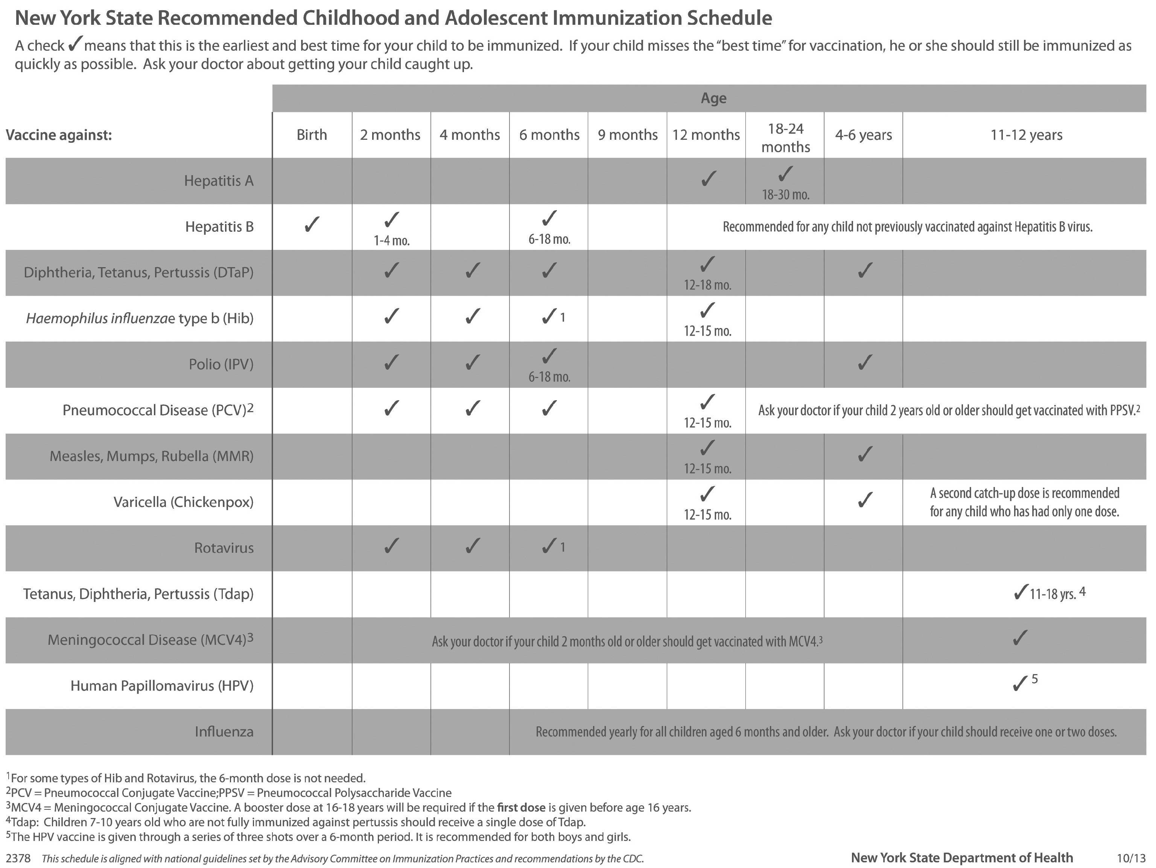
Arrival/Departure

Parents are responsible for bringing and picking up their children. They must bring their children to the Center’s classroom and SIGN IN at the roster by the door. NO CHILD IS ALLOWED TO BE DROPPED OFF AT THE DOOR OF THE BUILDING. When picking up your child at the end of the day, you must SIGN OUT and check with the teacher before leaving. This is to insure the safety and well-being of the children.

Our hours are from 6:00 A.M. until 6:00 P.M.
There is no child care service at AVCCC before or after hours.

After Hours Late Fee - Abide in the Vine Child Care Center may impose a late fee for picking up your child(ren) after closing… If you arrive after 6 p.m. you may be charged as follows:
$30 for the first 5 minutes (6:01 p.m. - 6:05 p.m.) plus $2 for each additional minute after the first 5 Minutes (6:06 p.m. and after)

Parents are responsible for their child before dropping their child off and after picking up their child.

Parents are responsible for arranging transportation with the School District for any School-Age Child to ride the bus to and/or from AVCCC.

Only an authorized adult may pick up your child. An authorized adult is one whose name is written on the child’s enrollment form. Any time another adult will pick up your child, we must have parental authorization in writing. Make sure your child and the staff at the Center know. We will not release your child to anyone unknown to us without written authorization. In case of an emergency, you may call the director and give verbal authorization. The director will allow it only if she/he recognizes your voice or can obtain verification.

The exceptions to this policy are:

- If we have a court order prohibiting the release of the child to the biological parent.

- If the staff determines that the person picking up the child is unfit by reason of alcohol or drugs to safely transport the child. If this happens, reasonable methods will be used to convince the driver not to leave with the child. If this fails, the matter will be turned over to the local authorities.

Emergencies & Closings

IN THE EVENT OF AN EMERGENCY: AVCCC utilizes multiple resources to alert our parents and staff of emergencies and closings. In the event of an emergency or closing we utilize WBNG TV (Binghamton Channel 12) which includes www.wbng.com. We also use a service that will send out automated phone calls and/or text message alerts. A opt in/out form is available in our Parent Packet Required Forms or by requesting one from the AVCCC office. There is no reimbursement for closings.

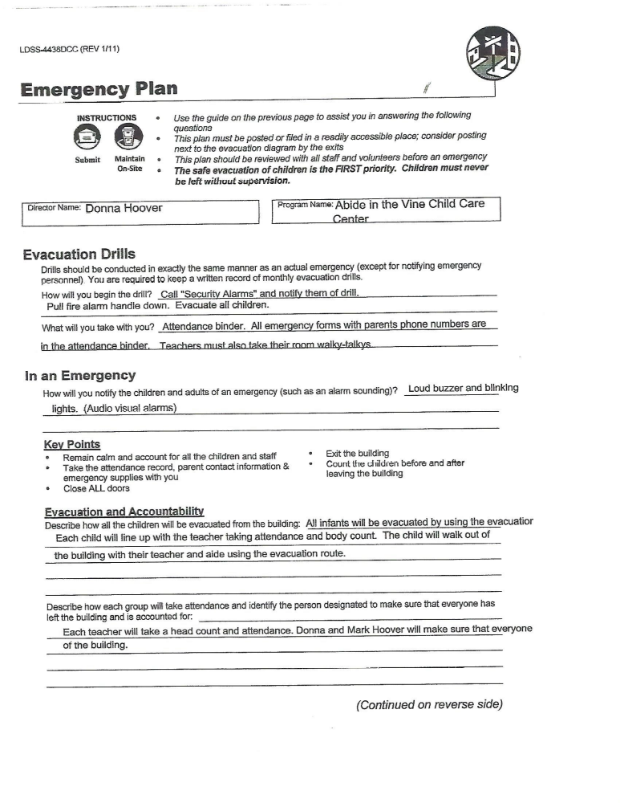

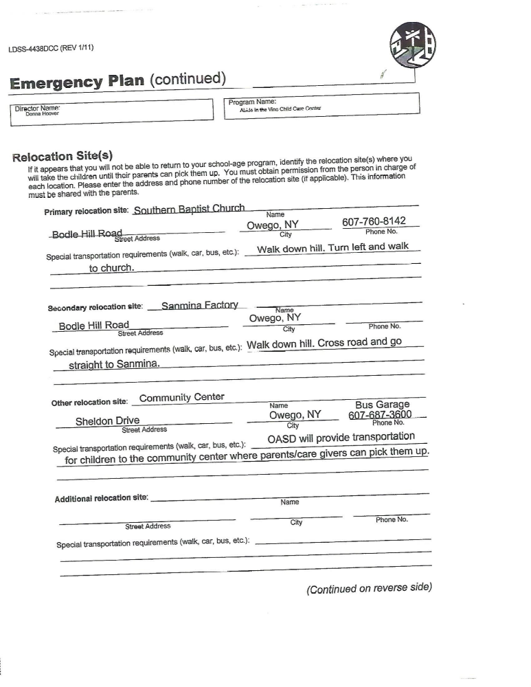

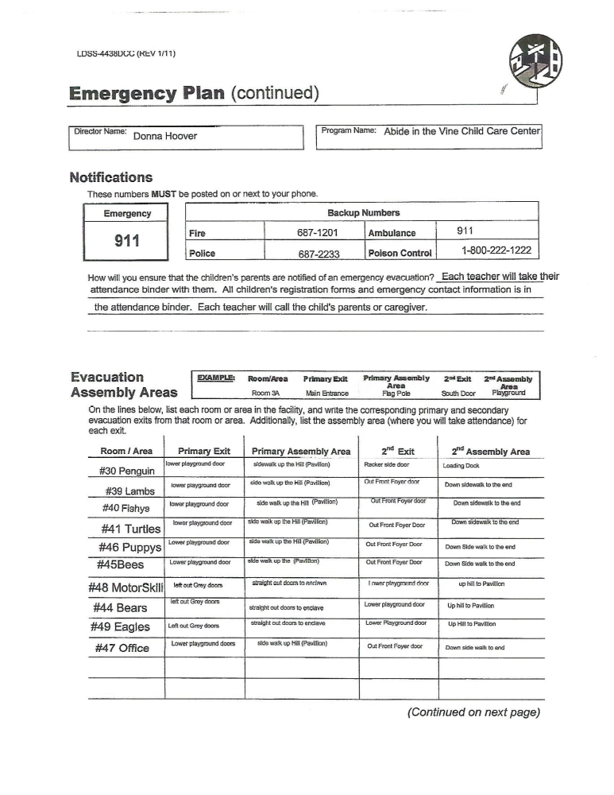

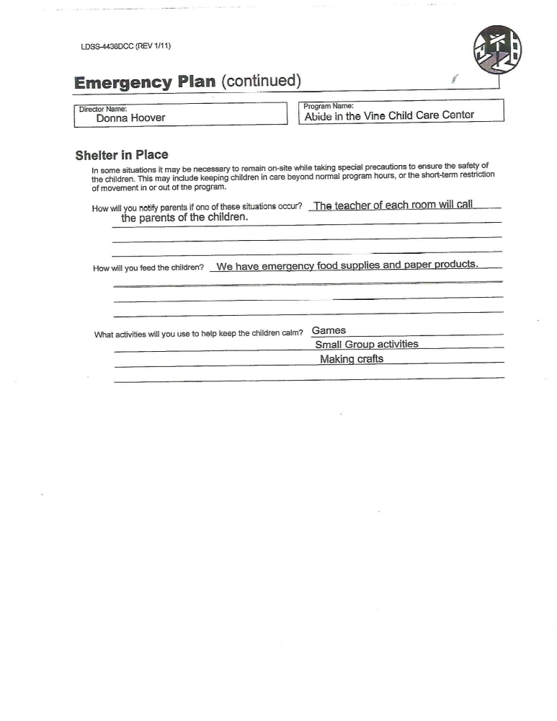

Personal Items

- Dress the child in casual play clothes. Reasonable care is taken to preserve their clothing, but children often have accidents.

- Dress the child for our changing weather. Boots, hats, mittens, and snow pants are a must in the winter. We go outside for at least a half hour each day except in inclement weather or extreme cold (below 20 degrees F). All outer wear must be marked with the child’s name, especially boots, mittens, and hats.

- All clothing, including boots, must be easily put on. Mittens are easier to manage than gloves.

- Children should have a change of clothing with them when they attend.

- We will maintain a clothing pool. If your child wears these extra clothes home, please wash them and return them as soon as possible.

- Children should bring a small blanket for napping.

- Children do brush teeth after meals. Please send a toothbrush and small tube of toothpaste. Please label them!

- Children may bring one special cuddly toy for nap time.

- Parents are responsible for providing diapers for your child.

Napping and Non-Napping Options

- Here at AVCCC you have an option whether your child naps or does not nap. If your child needs a nap we have provided cots in each room so that your child may lie down and nap. (No child will be kept lying on his/her cot over 10 minutes if he/she has not fallen asleep.)

- AVCCC also offers a non-napping room for children who do not nap. This room is set up just like a classroom. In this room your child will play, do crafts, and play games. If you do not want your child to nap please tell the Director so that your child can go to the non-napping room.

Parental Involvement

Parents are encouraged to visit the Center and participate in activities as often as time permits.

Parent-Teacher conferences are held at least twice a year, and as often as needed. The staff is always available to discuss your child’s progress. Please set up a time away from your child for these discussions.

Behavioral Management Policy

The staff at Abide in the Vine Child Care Center understands that the early childhood years are the time that a child is learning which behaviors are appropriate and which behaviors are not appropriate in a social setting. It is part of our responsibility to teach and model behaviors that are acceptable in an environment with other children. We recognize that the parents will be doing the same in the child’s home environment.

The staff will praise and encourage behaviors that are kind, helpful, truthful and responsible. (“Billy, You were such a kind friend to share the cars with Sally!”) The staff will guide the children into positive and acceptable alternatives for inappropriate behaviors. (“Billy! You may not draw on the wall. You may draw on this paper.”)

If a child persists in behavior that is disruptive, destructive, or dangerous, then the child may be separated from the group for a “time out” period in a location that protects other children and himself. This location must be in view of the staff. The child may again participate in activities when safe and cooperative behavior is resumed.

In the rare event that a child’s disruptive, destructive, or dangerous behavior becomes a regular threat to other children in our care – AVCCC reserves the right to remove the child from our program. This is done only after exhausting all options/alternatives and as a last resort.

PROCEDURES REGARDING A STAFF MEMBER /DIRECTOR WHO IS THE SUBJECT OF A CHILD ABUSE / MALTREATMENT REPORT

- Immediately the mandated reporter will call the HOT LINE:
Phone Number 1-800-635-1522
Record: Name of Interviewer
Time that the Interviewer gives you
Case ID#
Date

- 2nd the Director will call the New York State Office of Children and Family Services.
Main Desk # 351-423-1202

- There will be no conversation or interview with the child or family. Our roll is to report to the hot line not investigate.

- Get a written report from staff or person who is reporting. Have the report signed and dated by the reporter

- The Director may take one or more of the following actions with regard to staff of the center relevant to a report of child abuse or maltreatment involving a child.
  - Immediate suspension and removal from property without pay.
  - Immediate dismissal.
  - Initiation of appropriate disciplinary action where applicable following legal council.

- Notify the Chairman of the Executive board of AVCCC.

- Fill out Form 221 and send it to: Tioga County
Dept. of Social Services
P.O. Box 240
Owego, NY 13827-0240

The following form is our Incident Report. This form is used to report any illness, accident, injury, etc… that has happened to your child. Should your child be injured in any way – you will receive a copy of this form. As always – even with the best supervision, accidents happen. We thank you for your understanding.

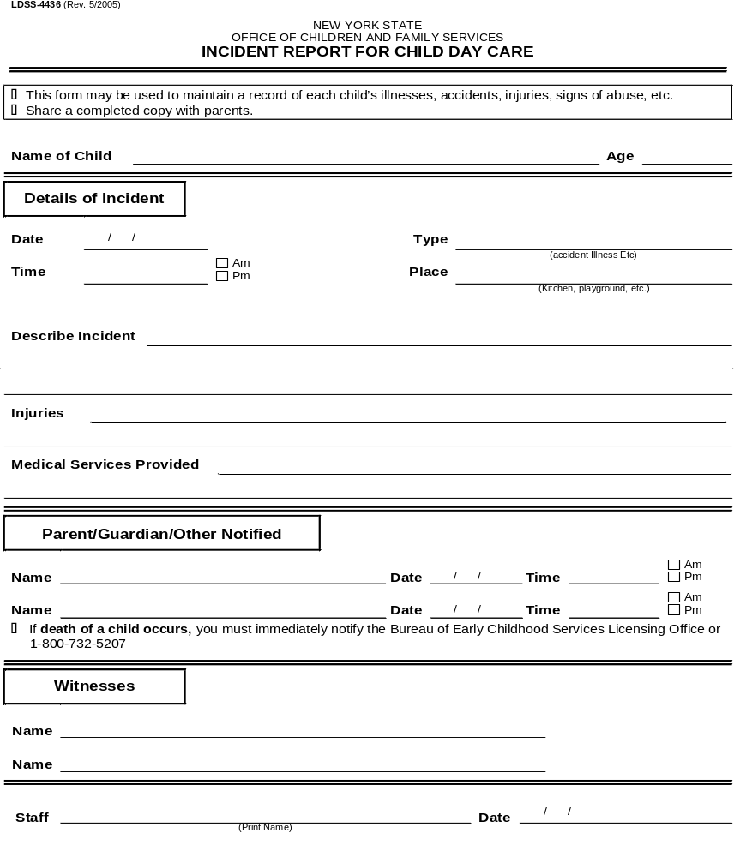

Cancer Prevention in Action
Abide in the vine child care center – sun safety policy

Rationale:
One bad sunburn during childhood doubles the risk of developing skin cancer later in life. Furthermore, children of all ages are susceptible to sunburns as well as skin cancer. Increasing this risk, by any amount, is not a chance Abide in the Vine Child Care Center (AVCCC) is willing to take. AVCCC is committed to implementing sun safety practices, to the best of their ability, by implementing the following policy.

Policy:
- Sunscreen
    - Sunscreen with an SPF of 15 or higher will applied to all children, who have documented parental permission, when necessary.
    - Sunscreen will not be applied to children whose parental figures have not given permission.
    - Sunscreen will be applied liberally to the face, neck, ears, hands, feet, and any other areas of exposed skin.
    - Sunscreen will be reapplied every two hours or more if children are playing in any source of water (water table, sprinkler, pool, etc.)
    - Sunscreen will not be applied to broken skin or if an allergic reaction is suspected. Parents will be notified of any concerns and staff must receive parental approval before sunscreen is applied again by a staff member.
    - Staff will also be encouraged to apply sunscreen before going outside with the children.

- Hats/Protective Clothing/Sunglasses
    - Children and staff will be encouraged to wear sun hats with wide brims or baseball caps.
    - Long sleeved clothing will be encouraged as well as sun protective clothing, dark colors, and tightly woven materials.
    - Parental figures will be encouraged to provide UVA/UVB sunglasses for their children.

- Shade Protection
    - Staff will encourage children to play in shaded areas: under trees, shade structures, tents, etc.
    - If directing an outdoor activity, staff will use shaded areas as much as possible.

- Scheduling
    - Staff will keep time of day in mind when planning outdoor activities, and try to limit time spent outdoors between the hours of 10am-2pm as much as possible.
    - Staff will monitor heat index and hold play time indoors when necessary.

Monitor and Review: This policy will be reviewed and modified by…

Contact Person: For any questions regarding this policy please contact…Mark Hoover

Policy Adopted: 9-9-2019

Updated:

